**LAB#02 – TASK#01**

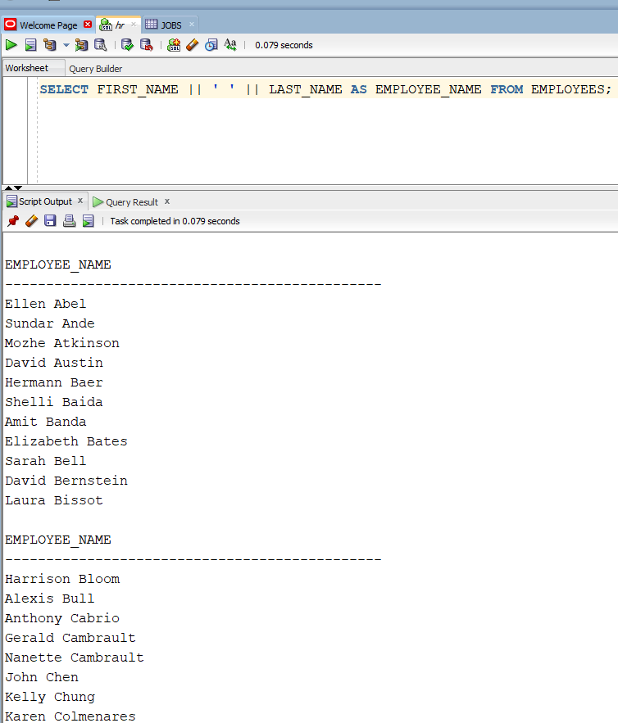

**LAB#02 – TASK#02**

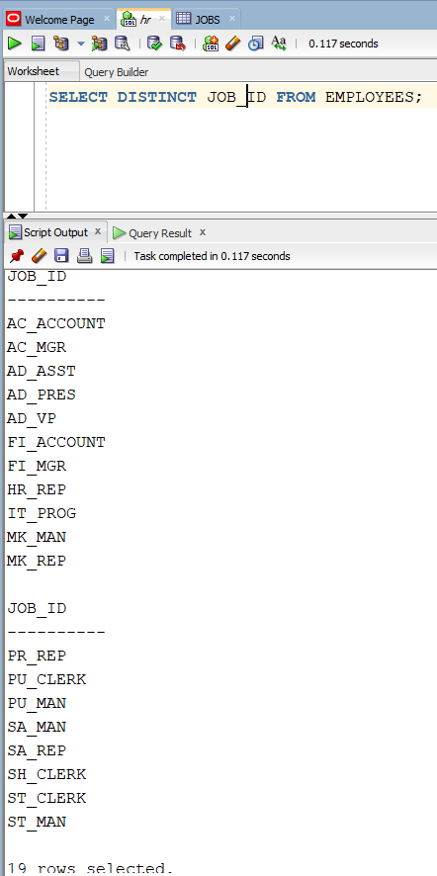

**LAB#02 – TASK#03**

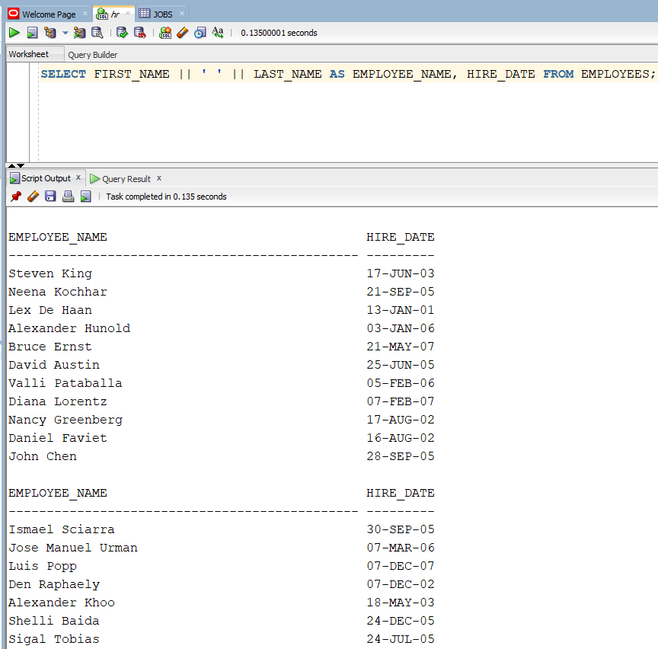

**LAB#02 – TASK#04**

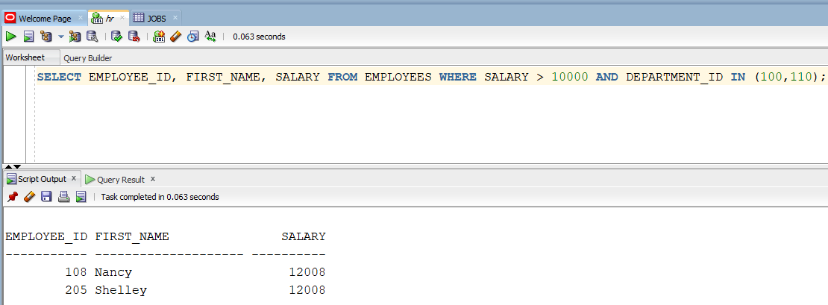

**LAB#02 – TASK#05**

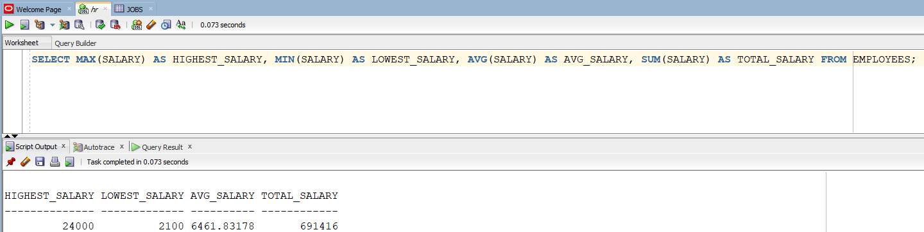

**LAB#02 – TASK#06**

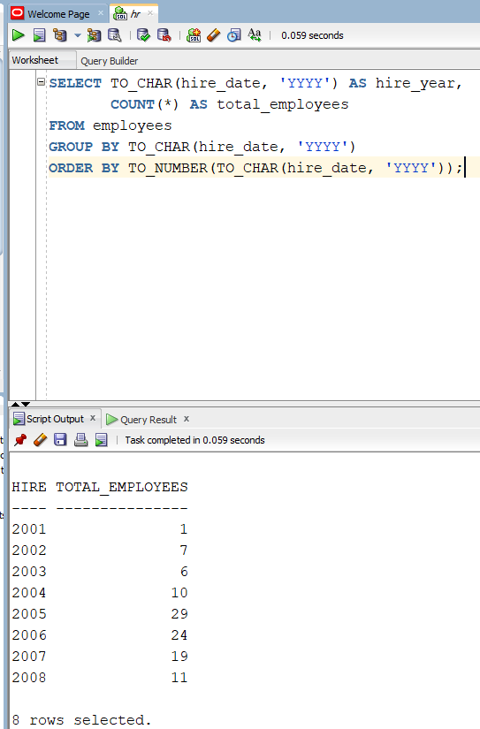

**LAB#02 – TASK#07**

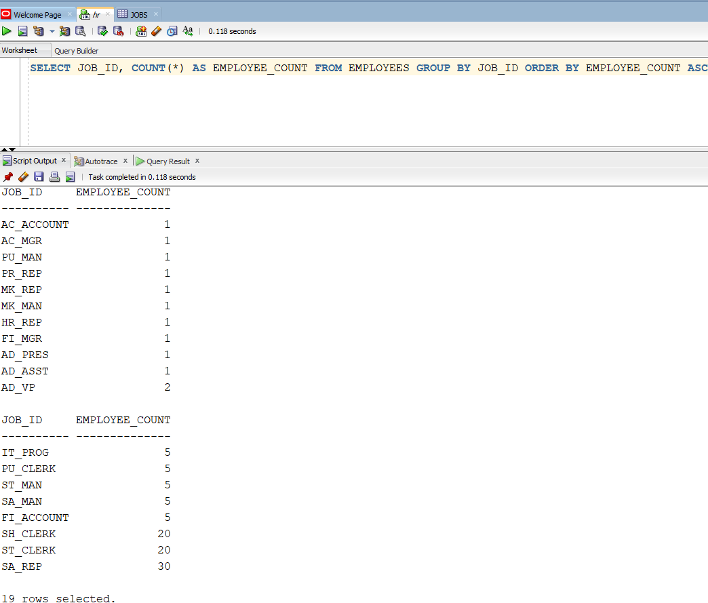

**LAB#02 – TASK#08**

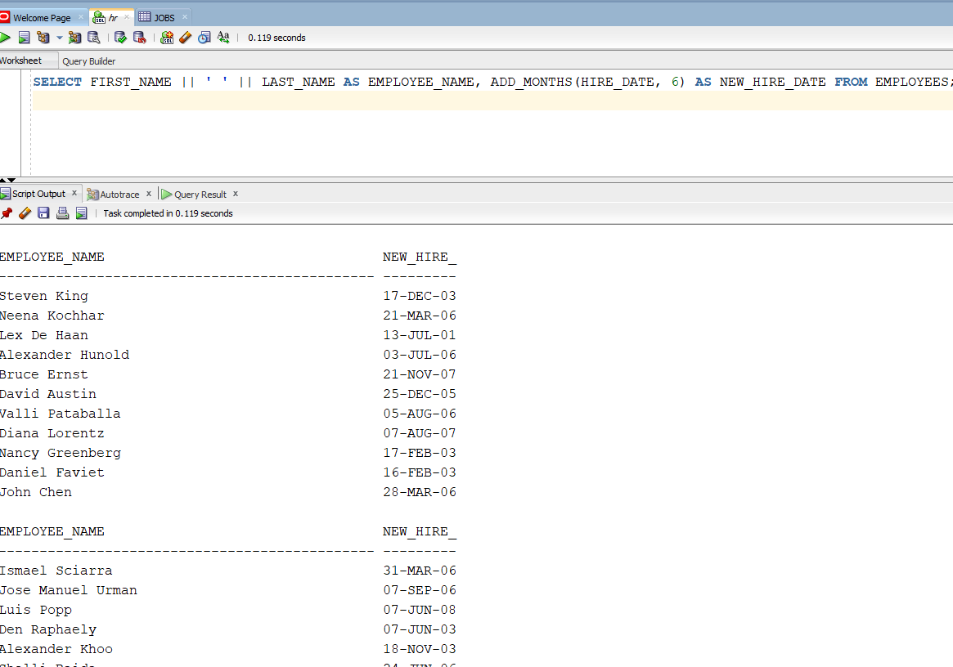

**LAB#02 – TASK#09**

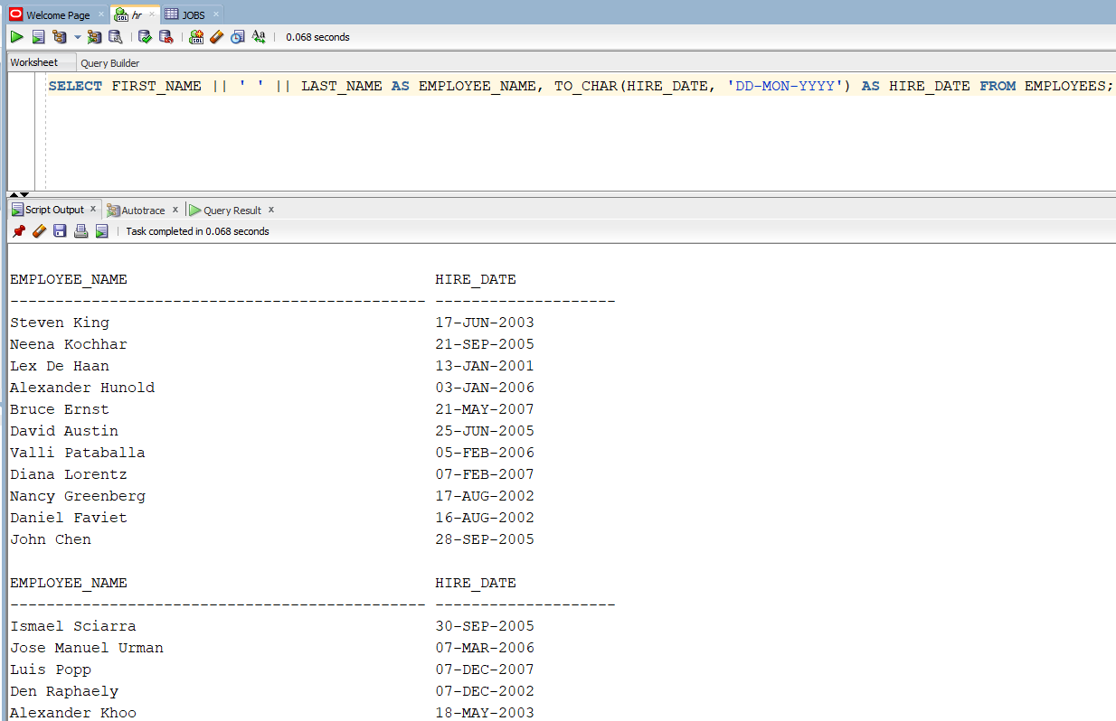

**LAB#02 – TASK#10**

